Michael Black

Syed Haider

Sarah Han

Greg Violan

Output for the Queries

1) List the customers. For each customer, indicate which category he or she fall into, and his or her contact information.

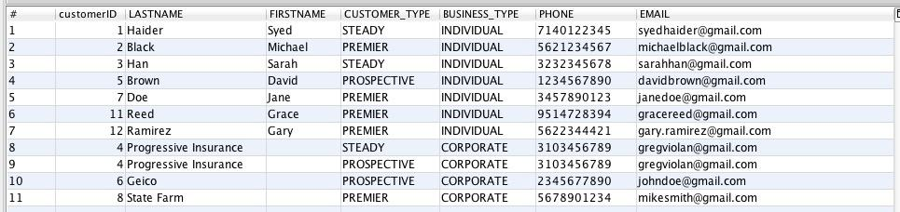

2) For each service visit, list the total cost to the customer for that visit.

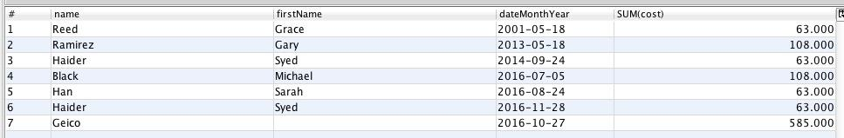

3) List the top three customers in terms of their net spending for the past two years, and the total that they have spent in that period.

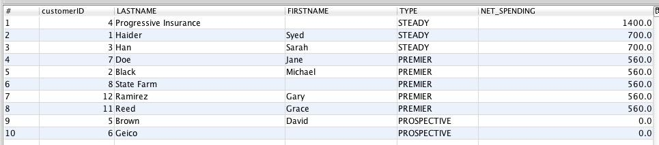

4) Find all of the mechanics who have three or more skills.



5) Find all of the mechanics who have three or more skills in common.



6) For each maintenance package, list the total cost of the maintenance package, as well as a list of all of the maintenance items within that package.



7) Find all of those mechanics who have one or more maintenance items that they lacked one or more of the necessary skills. 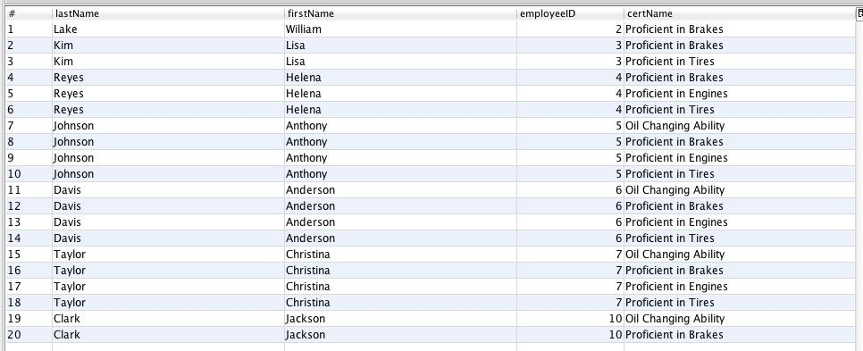

8) List the customers, sorted by the number of loyalty points that they have, from largest to smallest.



9) The premier customers and the difference between what they have paid in the past year, versus the services that they actually used during that same time. List from the customers with the largest difference to the smallest.



10) Report on the steady customers based on the net profit that we have made from them over the past year, and the dollar amount of that profit, in order from the greatest to the least.



11) List the three suppliers who have supplied us the largest number of parts (not total quantity of parts, but the largest number of distinct parts) over the past year.



12) List the five suppliers who have supplied us the largest dollar value of parts in the past year.

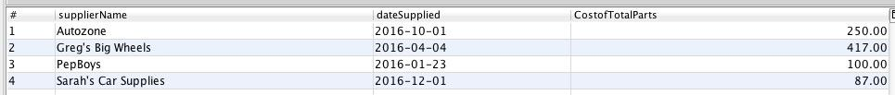

13) Find the mechanic who is mentoring the most other mechanics. List the skills that the mechanic is passing along to the other mechanics.



14) Find the three skills that have the fewest mechanics who have those skills.



15) List the employees who are both service technicians as well as mechanics.



16) Three additional queries that demonstrate the five additional business rules. Feel free to create additional views to support these queries if you so desire.

16a) 10% discount for seniors (+65)



16b) Employee pay raise after 5 years of working



16c) Happy Hour 10% discount between 7am to 11am



16d) 5 year premier anniversary customer special: free service that is worth $150 or less



16e) Customer loyalty points are spent immediately

